The following is intended as a guideline to assist you in initiating and planning your project.

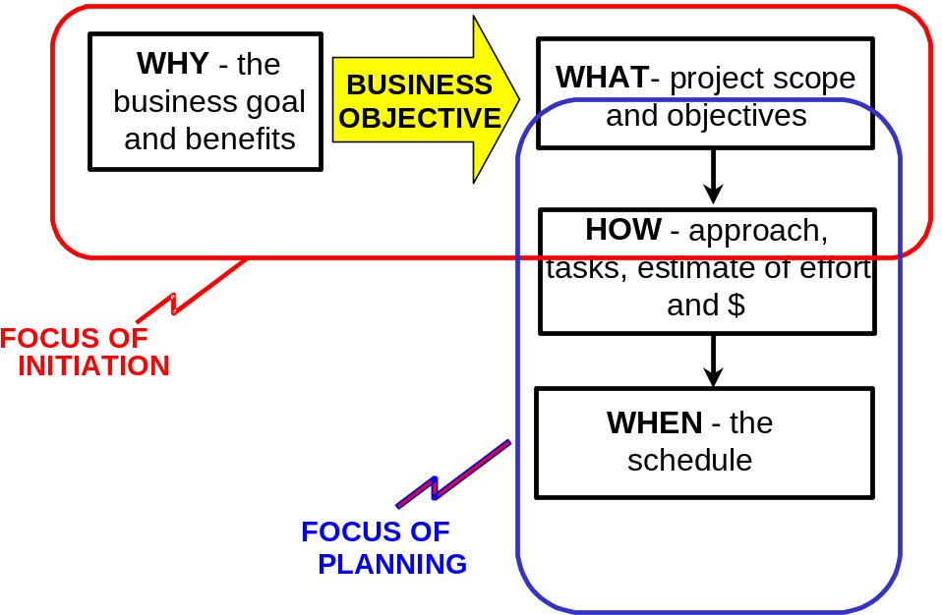

Project Initiation – Creating the Charter
- Investigate who wants the project, determine the Sponsor
- Determine why they want the project, what the business drivers are, what the problems are that create the need
- Establish project objectives that support the business need
- Define the project scope, focusing on completeness, not detail
- Do some preliminary project planning to define how the work will be done and establish a budget
- Identify project risks that are
- Allocate responsibilities and set expectations
- Document Project Charter and obtain Sponsor approval
- Create AFE to obtain funding approval

Project Planning

- Refine scope, creating work breakdown structure (WBS).
- Identify major phases and deliverables
- Define activities and tasks to create, review, and approve deliverables
- Evaluate project risk
- Build MSProject plan based on WBS. Add duration to tasks, identify constraints, and sequence tasks, identifying dependencies. Identify milestones.
- Identify resource needs and add resources to MSProject Plan
- Confirm resource usage and availability. Are occasional absences (both known and unknown) of team members due to vacations, training, meetings, illness, and other outages accounted for in the plan?
- Adjust duration, effort, activities based on resources and their input to the plan.
- Build Resource Plan
- Review and revise project budget
- Create a separate risk plan that contains actions to mitigate key risk events
- Define processes for controlling and managing change on the project

Ensuring Buy-in and Commitment
- Has the project team been involved in the estimation process?
- Has each team member agreed to take responsibility for producing his/her assigned piece of the project within the time estimated?
- Will the plan ensure creation of deliverables for clients at regular 2 to 3 week intervals?
- Are all assumptions and external dependencies in the plan explicitly documented?
- Do you know what complete looks like for each deliverable and milestone on the project plan?
- Update project charter as required
- Project Objectives and Scope
- Approach, constraints, approvals, and deliverables
- Project team names and roles
- Schedule and assumptions
- Budget
- Ensure Steering Committee understanding and commitment to the following:
- Updated Project Charter
- Resource Plan
- Risk Plan
- Project Control Processes

ITEM 2 CHARTER AND PLAN CHECKLIST

DOCUMENTATION ELEMENTS
X = element is usually introduced during this version. All elements may be updated subsequently.

Element | Charter  First version | Project Plan Second version | Comment
Business Purpose | X |  | High level goal served by project and the specific business objective in must achieve.
Project Objectives | X |  | Specific outcomes of project, using S.M.A.R.T. acronym.
Project Scope  Description  Deliverables | X  X |  | Narrative and list of deliverables.
In/Out  WBS |  | X  X | Final definition of the work to be done.
Approach | X |  | How the work will be done – the methods to be used.
Stakeholders | X |  | Who has an interest in the project.
Roles and Responsibilities | X |  | Responsibilities of the key stakeholders. May include a project structure chart and steering committee formation.
Budget  Allocation | X |  | If a budget allocation has been provided, state it here. Using ranges or uncertainty factors, indicate degree of budget risk.
Estimates |  | X | Based on bottom-up build, provide project estimate of work effort and $.
Schedule  Critical Dates | X |  | If certain dates must be met, state them here. State the desired end date.
Dependencies  Milestones  Gantt |  | X  X  X | Especially reliance on others.  Key events.  Visual bar chart of schedule.
Resource Plan  Requirements  Resource Matrix | X | X | State critical skill and major facility needs.  Time phased (monthly) matrix of team member work effort.
Assumptions | X |  | Basis for estimate of effort and schedule.
Constraints | X |  | Certain conditions that must be adhered to.
Risks  Key Risks | X |  | Preliminary risk analysis to identify high priority risk events.
Mitigation Plan |  | X | Actions to address high and medium priority risk events.
Project Issues |  | X | Current impediments to success
Approvals | X |  | Process for approvals, what has to be approved, who approves.
Communications Plan |  | X | Who has to be kept informed and how.
Tracking and Time Reporting |  | X | Use of the time tracking system.
Progress and Status Reporting |  | X | How the team will report, and what reports will be provided to stakeholders.
Change Management |  | X | How changes to scope will be handled
Issue Management |  | X | How issues will be logged and escalated.
Quality Management |  | X | Key quality issues and the planned response.

